**NEERJA NARAYANAPPA**

**NXN5625**

**1001575625**

**Assignment 2**

# Question 1

## Max: [4308: 20 Points, 5360: 16 Points]

Consider the search tree shown in Figure 1. The number next to each edge is the cost of the performing the action corresponding to that edge. You start from the node A. The goal is the reach node G. List the order in which nodes will be visited using:

breadth-ﬁrst search. depth-ﬁrst search.

iterative deepening search. uniform cost search.

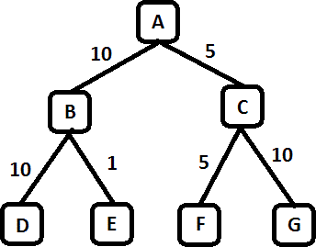

Figure 1: Search Tree for Problem 1

**SOLUTION:**

# BFS: ABCDEFG

# DFS: ABDECFG

# IDS:

* first iteration: A
* second iteration: ABC
* third iteration: ABDECFG

# UCS: A,C(5),B(10),F(10),E(11),G(15)

# Question 2

## Max: [4308: 30 Points, 5360: 25 Points]

A social network graph (SNG) is a graph where each vertex is a person and each edge represents an acquaintance. In other words, an SNG is a graph showing who knows who. For example, in the graph shown on Figure 2, George knows Mary and John, Mary knows Christine, Peter and George, John knows Christine, Helen and George, Christine knows Mary and John, Helen knows John, Peter knows Mary.

The degrees of separation measure how closely connected two people are in the graph. For example, John has 0 degrees of separation from himself, 1 degree of separation from Christine, 2 degrees of separation from Mary, and 3 degrees of separation from Peter.

1. From among general tree search using breadth-ﬁrst search, depth-ﬁrst search, iterative deepening search, and uniform cost search, which one(s) guarantee ﬁnding the correct number of degrees of separation between any two people in the graph?

**SOLUTION:** All except Depth First Search.

IDS if started at large initial depth.

1. For the SNG shown in Figure 2, draw the ﬁrst three levels of the search tree, with John as the starting point (the ﬁrst level of the tree is the root). Is there a one-to-one correspondence between nodes in the search tree and vertices in the SNG (i.e. does every node in the search tree correspond to a vertex in the SNG)? Why, or why not? In your answer here, you should assume that the search algorithm does not try to avoid revisiting the same state.

## SOLUTION:

## There is no one to one correspondence between the nodes and the vertices due to the possibility of loops in SNG. One vertex in SNG, John corresponds to multiple nodes in search tree.

1. Draw an SNG containing exactly 5 people, where at least two people have 4 degrees of separation between them.

**SOLUTION:**

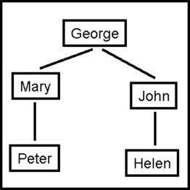

## Peter and Helen have 4 degrees of separation

1. Draw an SNG containing exactly 5 people, where all people have 1 degree of separation between them.

**SOLUTION:**

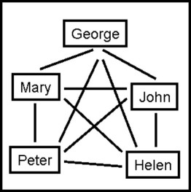

1. **CSE 5360 Only (5 point EC for CSE 4308):** In an implementation of breadth-ﬁrst tree search for ﬁnding degrees of separation, suppose that every node in the search tree takes 1KB of memory. Suppose that the SNG contains one million people. Outline (brieﬂy but precisely) how to make sure that the memory required to store search tree nodes will not exceed 1GB (the correct answer can be described in one-two lines of text). In your answer here you are free to enhance/modify the breadth- ﬁrst search implementation as you wish, as long as it remains breadth-ﬁrst (a modiﬁcation that, for

**SOLUTION:**

## Maintain the list of people already seen in search.

## Generating successor nodes while revisiting nodes that corresponding to that person should not be done.

Figure 2: A Social Network Graph

# Question 3

## Max: [4308: 30 Points, 5360: 24 Points]

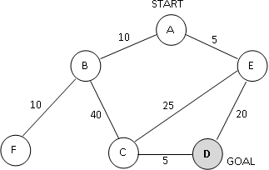

Figure 3. A search graph showing states and costs of moving from one state to another. Costs are undirected.

Consider the search space shown in Figure 3. D is the only goal state. Costs are undirected. For each of the following heuristics, determine if it is admissible or not. For non­admissible heuristics, modify their values as needed to make them admissible.

## SOLUTION:

## True distances to the goal are

## h*(A) = 25

**h*(B) = 45**

**h*(C) = 5**

**h*(D) = 0**

**h*(E) = 20**

**h*(F) = 45**

**For Heuristic to be admissible it has to give value less than or equal to this value**

Heuristic 1:

h(A) = 5

h(B) = 40

h(C) = 10**(change to 5 or less)**

h(D) = 0

h(E) = 10

h(F) = 0

Heuristic 2:

h(A) = 8

h(B) = 5

h(C) = 3

h(D) = 5 **(change to 0)**

h(E) = 5

h(F) = 0

Heuristic 3:

h(A) = 35 **(change to 25 or less)**

h(B) = 30

h(C) = 20 **(change to 5 or less)**

h(D) = 0

h(E) = 0

h(F) = 50 **(change to 45 or less)**

Heuristic 4:

h(A) = 50 **(change to 25 or less)**

h(B) = 50 **(change to 45 or less)**

h(C) = 50 **(change to 5 or less)**

h(D) = **50 (change to 0)**

h(E) = 50 **(change to 20 or less)**

h(F) = 50 **(change to 45 or less)**

Heuristic 5: **(admissible as it is)**

h(A) = 0

h(B) = 0

h(C) = 0

h(D) = 0

h(E) = 0

h(F) = 0

# Question 4

## Max: [4308: 20 Points, 5360: 15 Points]

Consider a search space, where each state can be a city, suburb, farmland, or mountain. The goal is to reach any state that is a mountain. Here are some rules on the successors of different states:

Successors of a city are always suburbs.

Each city has at least one suburb as a successor.

Successors of a suburb can only be cities, or suburbs, or farms.

Each suburb has at least one city as a successor.

Successors of a farm can only be farms, or suburbs, or mountains.

Each farm has at least one other farm as a successor.

Successors of a mountain can only be farms.

Deﬁne the best admissible heuristic h you can deﬁne using only the above information (you should not assume knowledge of any additional information about the state space). By "best admissible" we mean that h(n) is always the highest possible value we can give, while ensuring that heuristic h is still admissible.

You should assume that every move from one state to another has cost 1.

H(city) = **3**

H(suburb) = **2**

H(farm) = **1**

H(mountain) = **0**

# Question 5 (Extra Credit for 4308, Required for 5360)

## Max: [4308: 20 Points EC, 5360: 20 Points]

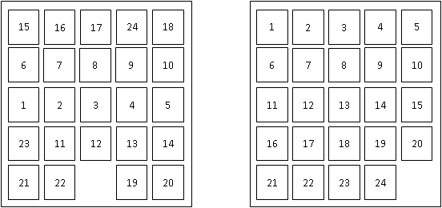

Figure 4. An example of a start state (left) and the goal state (right) for the 24­puzzle.

The 24­puzzle is an extension of the 8­puzzle, where there are 24 pieces, labeled with the numbers from 1 to 24, placed on a 5x5 grid. At each move, a tile can move up, down, left, or right, but only if the destination location is currently empty. For example, in the start state shown above, there are three legal moves: the 12 can move down, the 22 can move left, or the 19 can move right. The goal is to achieve the goal state shown above. The cost of a solution is the number of moves it takes to achieve that solution.

For some initial states, the shortest solution is longer than 100 moves. For all initial states, the shortest solution is at most 208 moves.

An additional constraint is that, in any implementation, storing a search node takes 1000 bytes, i.e., 1KB of memory.

Consider general tree search using the stategies of breadth­first search, depth­first search, iterative deepening search and uniform cost search.

(a): Which (if any), among those methods, can guarantee that you will never need more than 50KB of memory to store search nodes? Briefly justify your answer.

## SOLUTION:

## None.

## This is because even IDS and IDA*, which would need the smallest amount of memory, may need upto 4 x 208 = 832 nodes. That would be about 832 KB memory.

(b): Which (if any), among those methods, can guarantee that you will never need more than 1200KB of memory to store search nodes? Briefly justify your answer.

## SOLUTION:

## IDS and IDA*. Atmost they would need a memory of 832 KB.

## BFS and UCS would require a memory exponential to depth of solution.

## DFS requires memory linear to max depth of tree (this would be infinite in our problem since moves could be reversed)